# 5. Estimate surface normals:

Debug:

Column method:

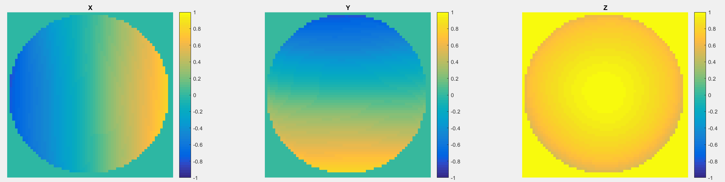

Row method:

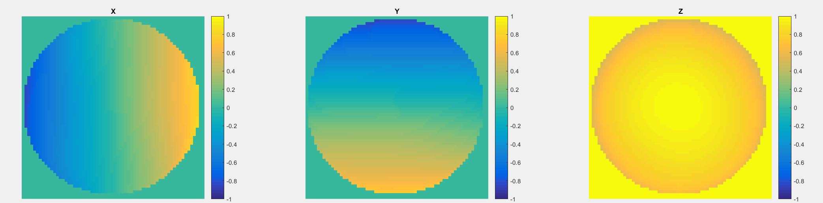

Average method:

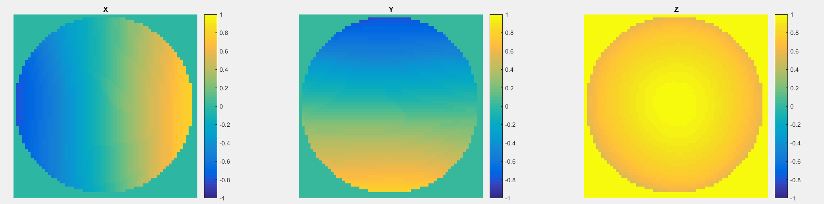

Random method:

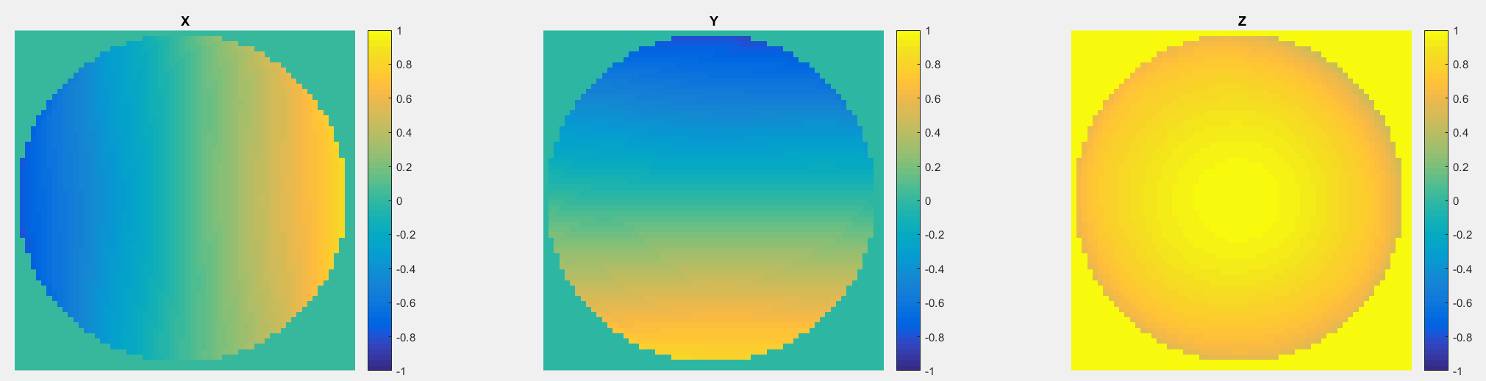

yaleB01:

Column method:

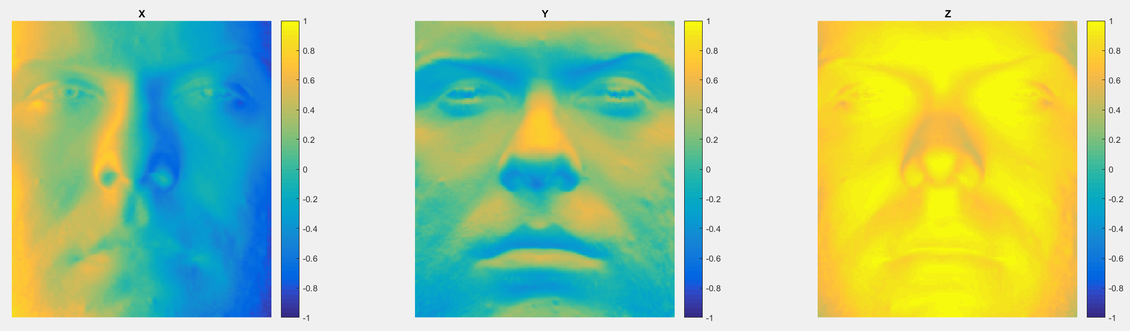

Row method:

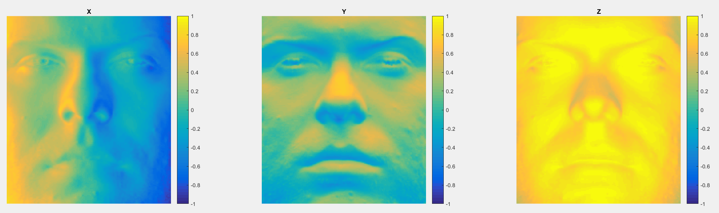

Average method:

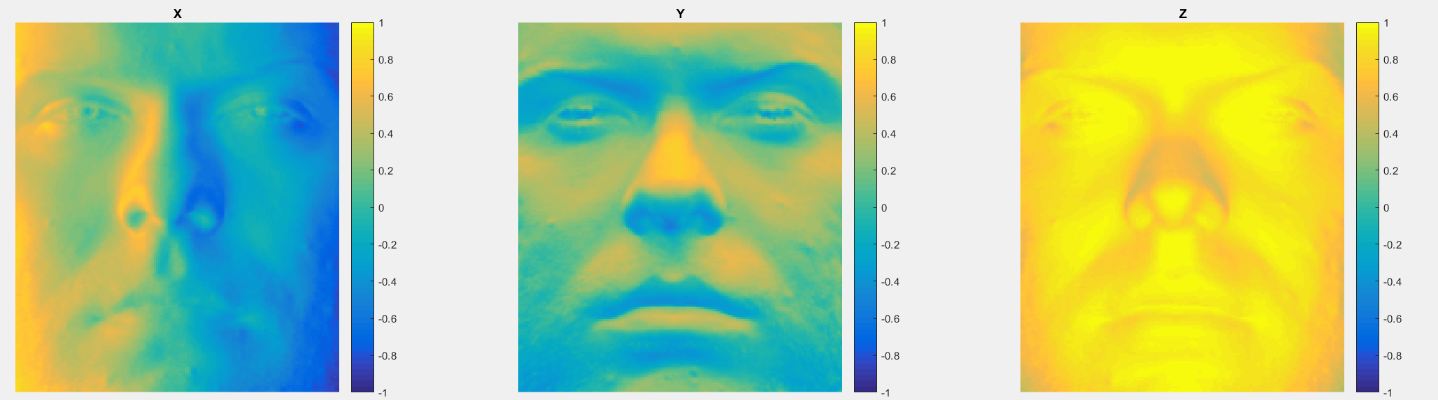

Random method:

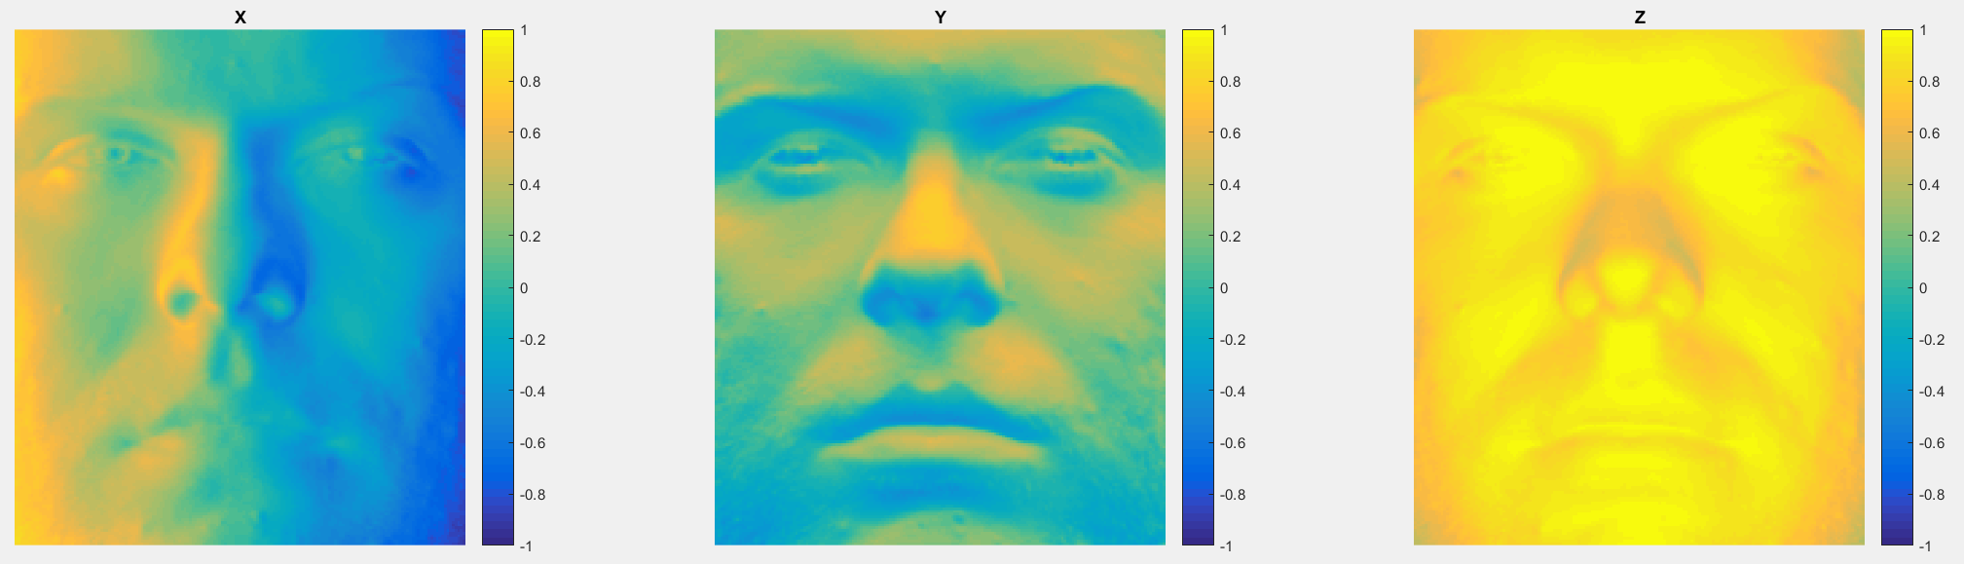

yaleB02:

Column method:

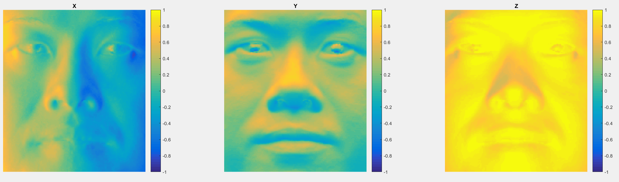

Row method:

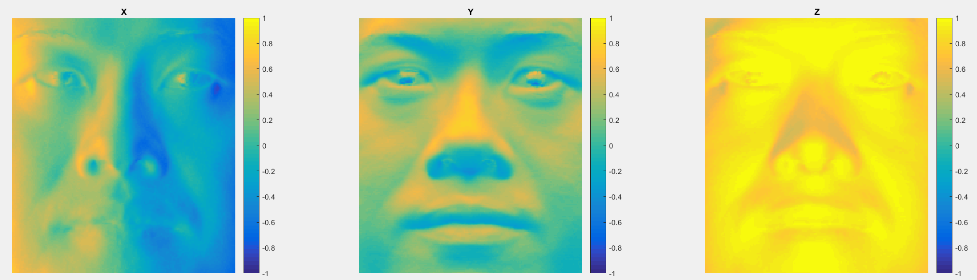

Average method:

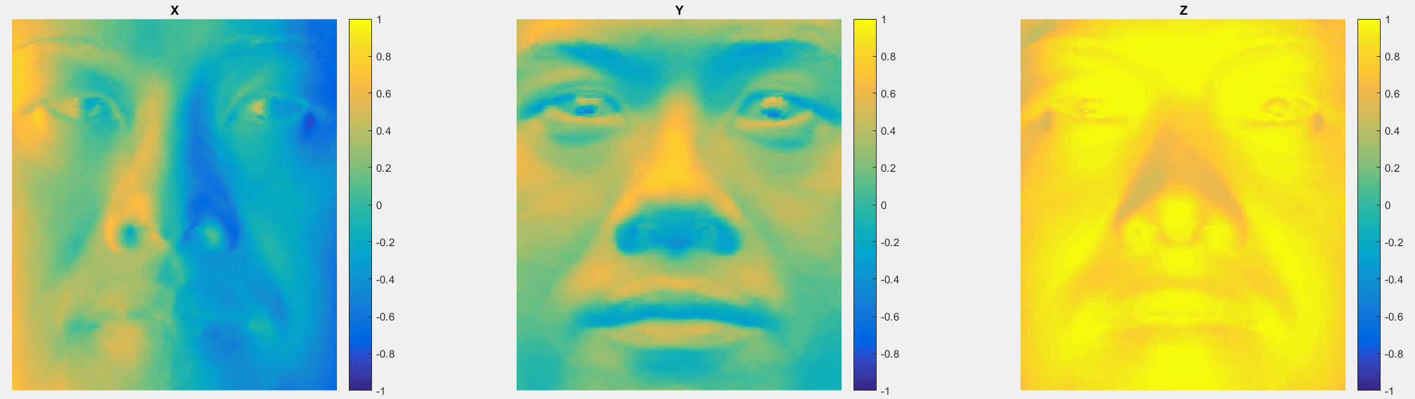

Random method: 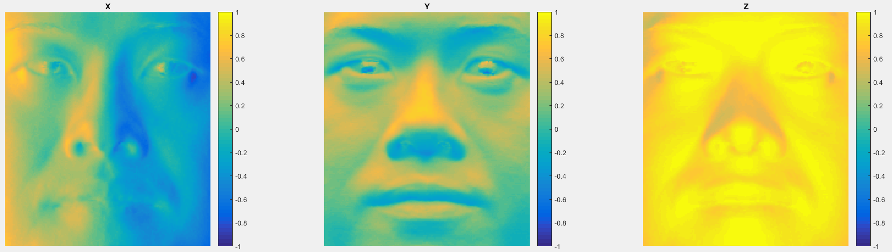

yaleB05:

Column method:

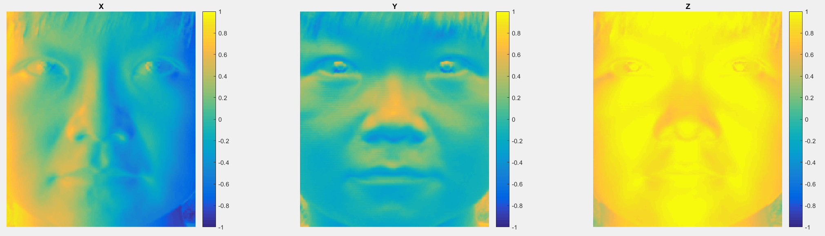

Row method:

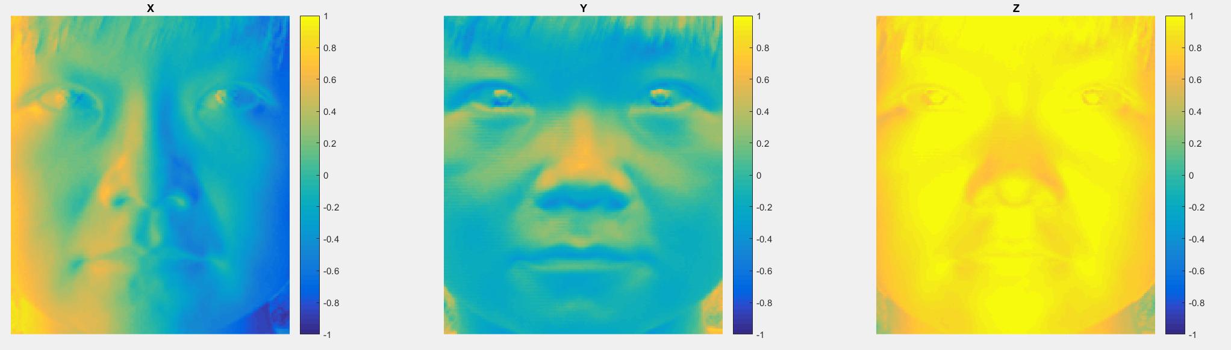

Average method:

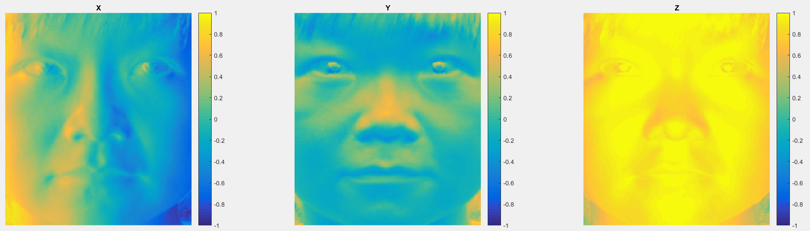

Random method:

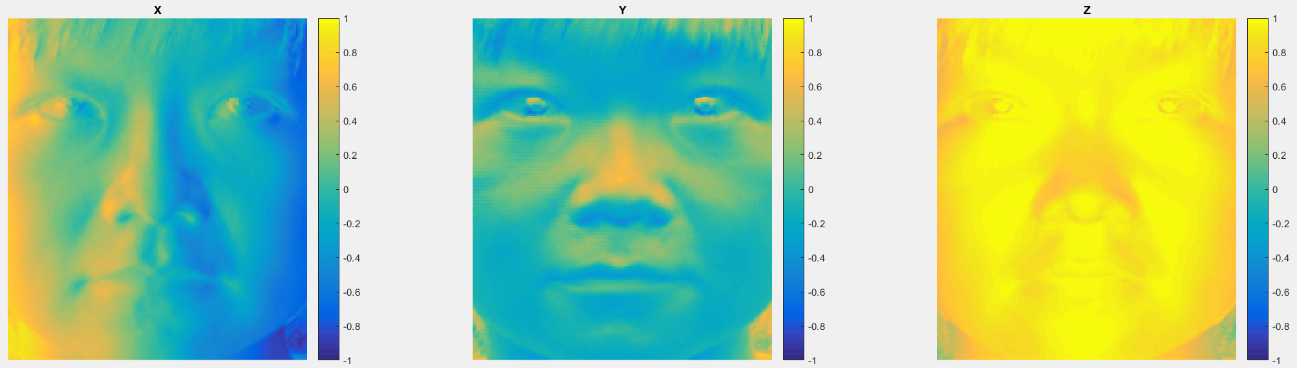

yaleB07:

Column method:

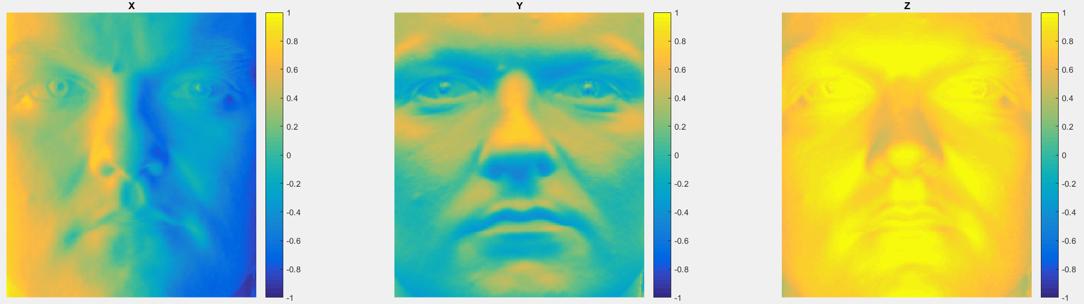

Row method:

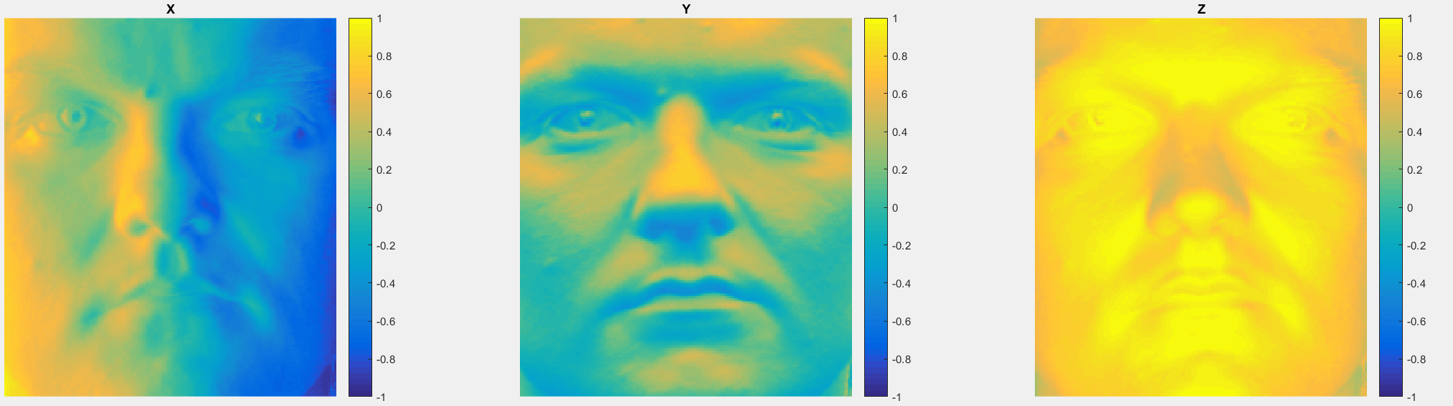

Average method:

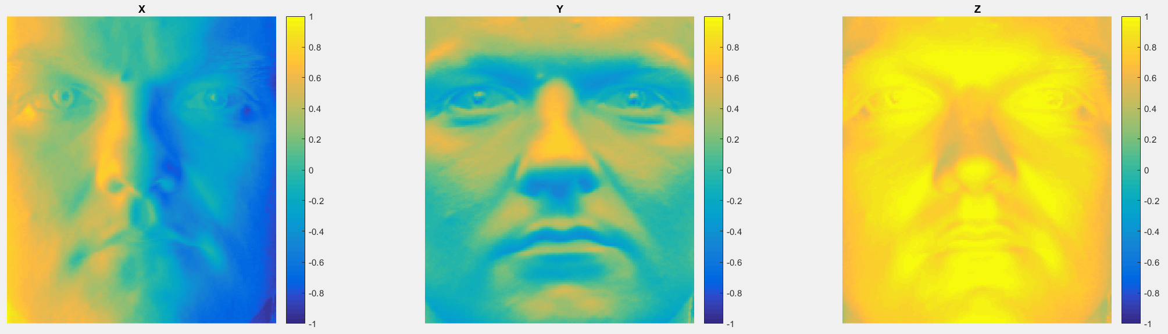

Random method:

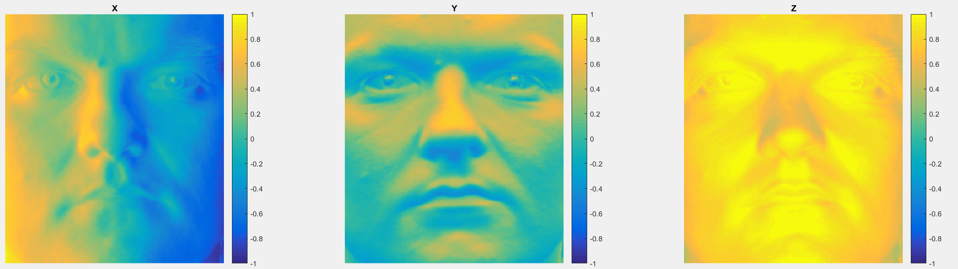

# 3. Compute the surface height map:

**3.1: Integrating first the rows, then the columns**

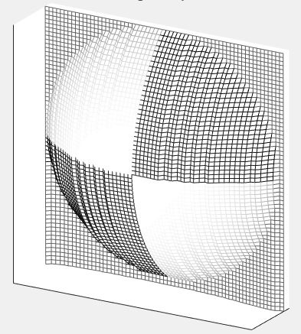Debug:

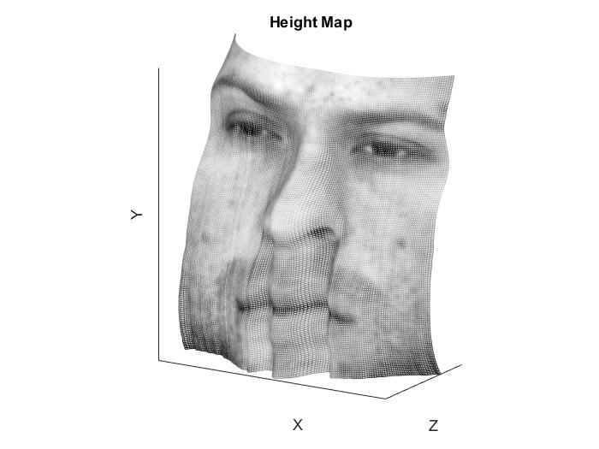yaleB01:

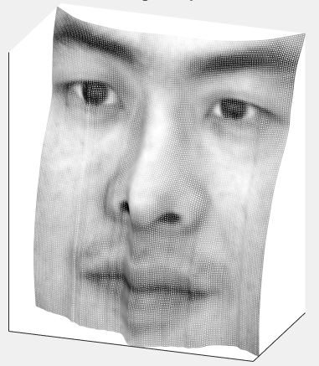yaleB02:

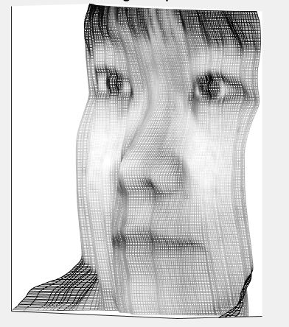yaleB05:

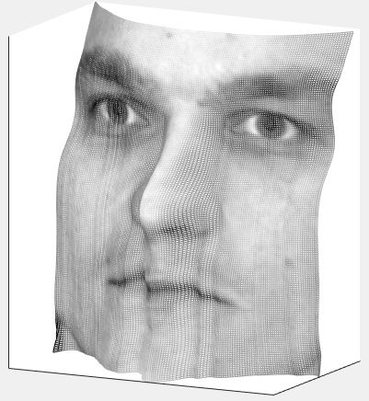yaleB07:

**3.2: Integrating first along the columns, then the rows**

Debug:

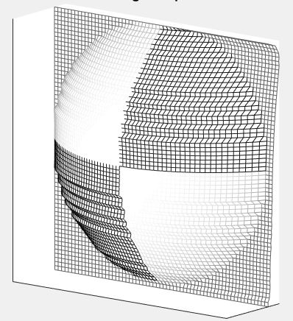

yaleB01:

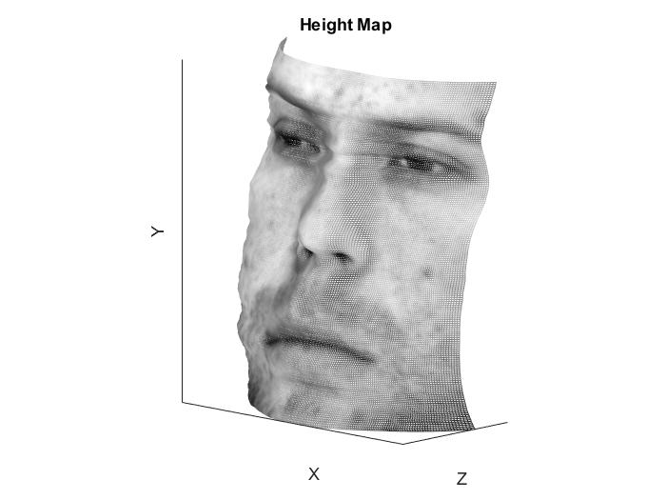

yaleB02:

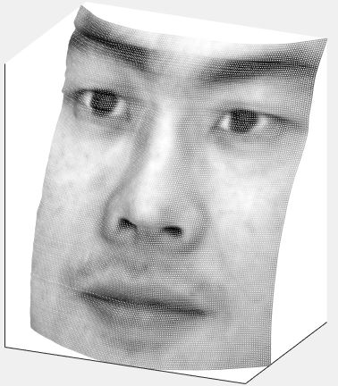

yaleB05:

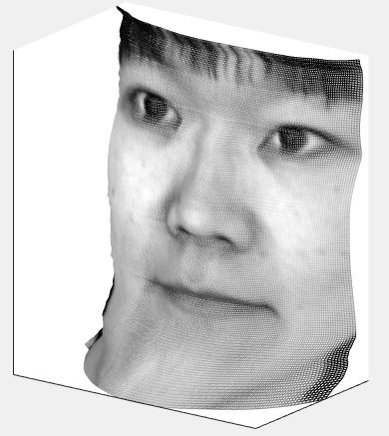

yaleB07:

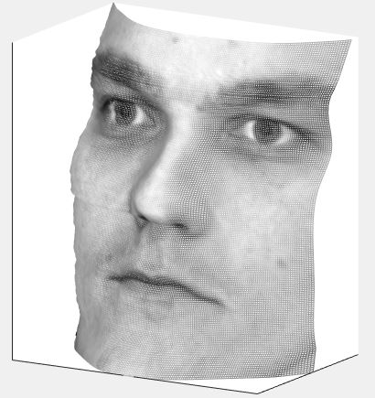

### 3.3: Average of the first two

Debug:

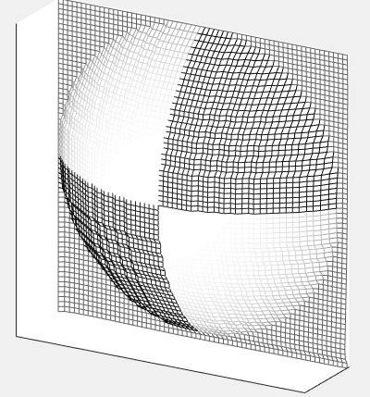

yaleB01:

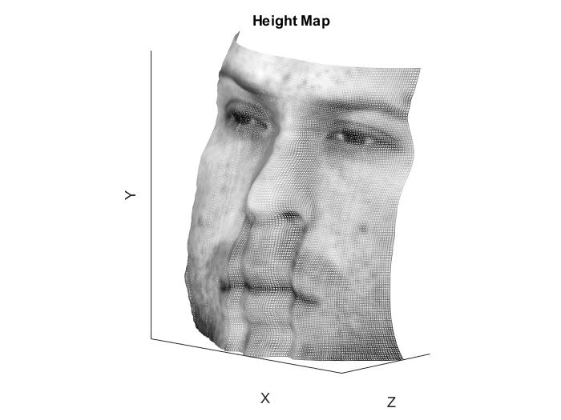

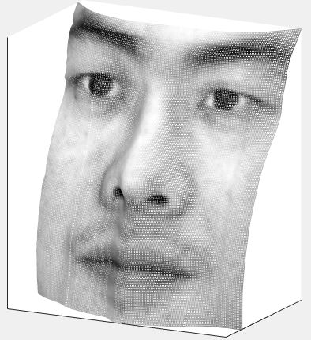yaleB02:

yaleB05:

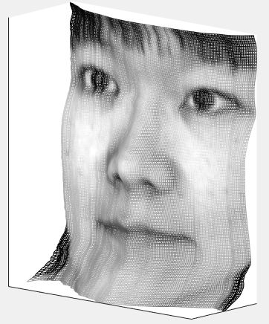

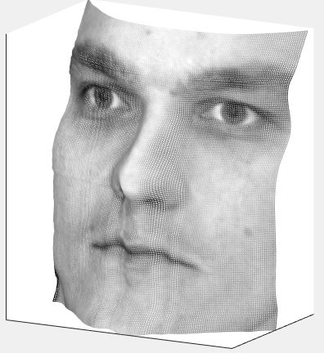yaleB07:

### 3.4: Average of multiple random paths

Debug:

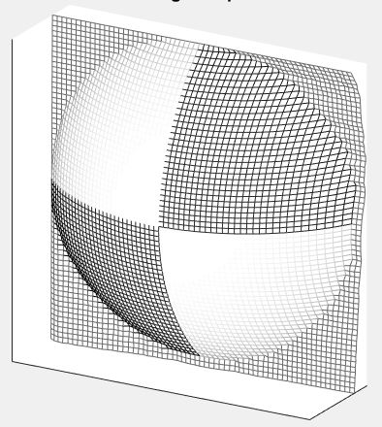

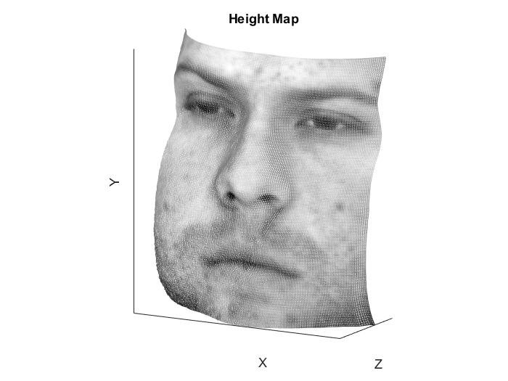yaleB01:

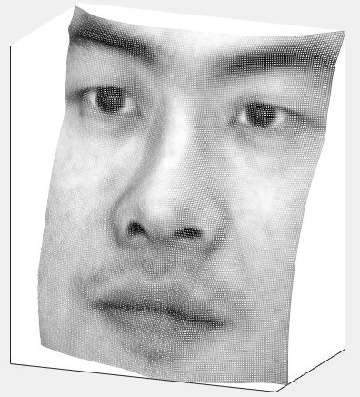yaleB02:

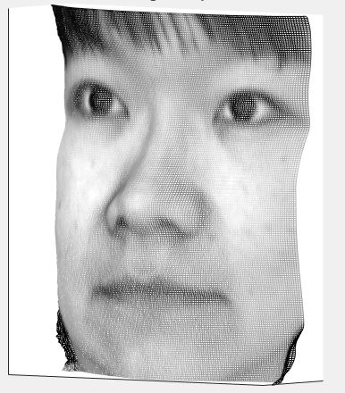yaleB05:

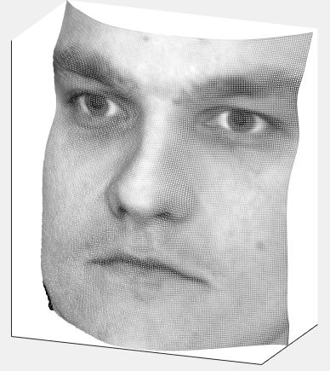yaleB07:

### 4.2: compare the running times of the different approaches

Debug:

Column method: 0.005479s Row method: 0.004242s

Average Method: 0.004524s Random method: 3.780084s

yaleB01

Column method: 0.001402s Row method: 0.000800s

Average Method: 0.004520s Random method: 56.651472s

yaleB02:

Column method: 0.004539s Row method: 0.009374s

Average Method: 0.006696s Random method: 60.639696s

yaleB05:

Column method: 0.005643s Row method: 0.004946s

Average Method: 0.007646s Random method: 60.451948s

yaleB07:

Column method: 0.006909s Row method: 0.006596s

Average Method: 0.005047s Random method: 60.570412s

# 5: In report: display the estimated albedo maps and screenshots of height maps

Debug:



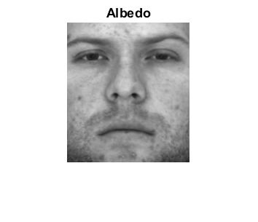yaleB01:

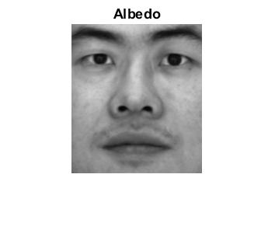yaleB02:

yaleB05:

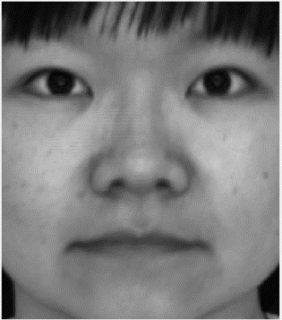

yaleB07:

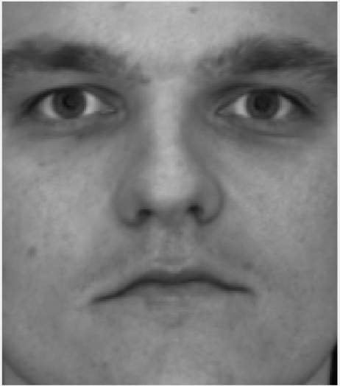

Normal: